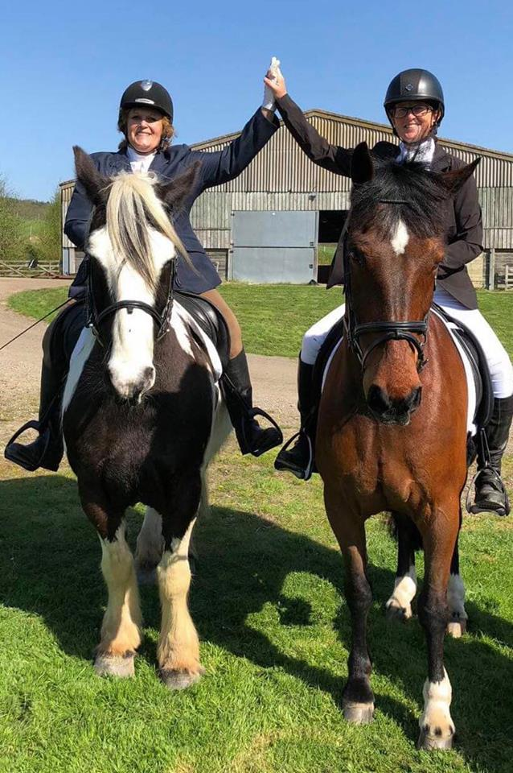
Matfield and District Riders Association
M.D.R.A

Spring Newsletter 2018
**New Membership Edition**

MDRA
COMMITTEE MEMBERS LIST
Chairperson
Sarah Ribchester –Mob; 07775804943 01892 832626
email; sarahribchester@kent.gov.uk
Co Chairperson/Membership Secretary
Di Miles- Mob;07979746390 email; jpmiles@seedersti.co.uk
Show Ground
Terry & Caroline Chapple – Mob; 07860359866 email; terrychapple2@aol.com
Treasurer
Anne Wallace –Mob;07967075044 email; annejwallace@hotmail.com
Secretary
Leanne Trainor- 07814963768 email; ray@tandrcarpentry.co.uk
Newsletter/ Website Guru
Jenny Corbett- Mob; 07905243746 email;lovinyourwork@hotmail.com
Events Secretary
Sharon Rickard – Mob; 07834494824 email;sharon@rickardsfoldingdoors.co.uk

Dressage Events & Kids Club Co-Ordinator
Kerry Balmer – email Mob; 07935553558 wardkerry2003@yahoo.co.uk

Stage Ideas & Backing Crew
Louise Phippen – Mob; 07979606494 email ;louise9-8@hotmail.com
Celia Wagstaff – Mob; 07595069328 email; celiasemail@gmail.com
Dawn Hodson – Mob 077761583756 email; dawn756@live.com

Chat from the chairs

Hi Everyone,
We have sun!!!!!! We deserve it after the wet, snowy, muddy conditions we have had to put up with over the last couple of months. Been a real test of staying power owning horses recently, we are made of stern stuff.
PARTY!!!- we had a lovely gathering to celebrate our 35th anniversary. It was great to see some past members and chat about the “good old days”. The Star did us proud with a lovely spread and music from Simon completed it all.
AGM
13th April saw a few of us in Matfield Village Hall for the AGM. Have to be honest , most of the attendees were committee members, so a little disappointing but Carolines sticky sausages made up for it. Prizes were given for the usual categories and everyone seemed pleased with the booty they received.
As always, most of the events we organise can only go ahead with the kindness of Terry, Caroline and Di, letting us use their facilities, so big thanks and we hope we can still invade you at regular intervals.
EVENTs
We are forging ahead with preparations for the Summer Show, so please tell all your friends, offer to help set up or on the day and lets make it one to remember for all the right reasons!
Dressage- Lovely dressage event on 22th April 2018 organised by Kerry and Sharon. Some very positive comments on what a great atmosphere we managed to project and for once the weather was on our side.
We have Clear round jumping at Terrys 12th May and Ann Wallace has bravely offered to regenerate the The Challenge- a must for some serious fun, to see what you and your equine buddy can achieve across all disciplines, date tbc.
Our membership numbers have room to improve! We work hard to try and cater to everyones wishes, but without feedback, help and people promoting how wonderful a club we are, the committee just keep going to maintain current level of members, so please if you have any ideas on how we can improve our profile in the public arena and generate more members, email/message us.
On personal note, I am trying to come to terms with the fact I have a turbo charged Nobby Cob, who knows exactly my weaknesses and fears, which he cunningly manipulates at every opportunity. If he was a human he would be a cross between Stephen Fry and Black Adder….. .Despite this we get on very well and between us we will grow old disgracefully together!
Enough from me, over to Di.
As Sarah said, we marked last year with a party for our 35th Anniversary , not bad for a small club.
As a club we do try and cater for the not so confident among us, so if there is anything you fancy having a go at let us know, no matter how trivial you think it may be, 18” jumps, go for it !
I on the other hand had a lovely present given me from my insignificant other, John, Archery on horseback ! Jen and I lorried off to Issacs Livery Yard at Bidborough and had a lovely afternoon of bows and arrows, and managed not to wound anyone! Highly recommended for anyone who dreams of being in Game Of Thrones ! We had great fun.
Don’t forget to renew your membership before the show, no membership entry’s on the day please, you will benefit from the cheaper entry fee if you join by July 18th !
Look out for our Events on FB and our website!
Bring on the Summer Sun and riding fun!
Don’t forget our website:
www.mdra.info
Have a look to download membership forms and schedules. Get your discounts with membership.
Ribs & Di.

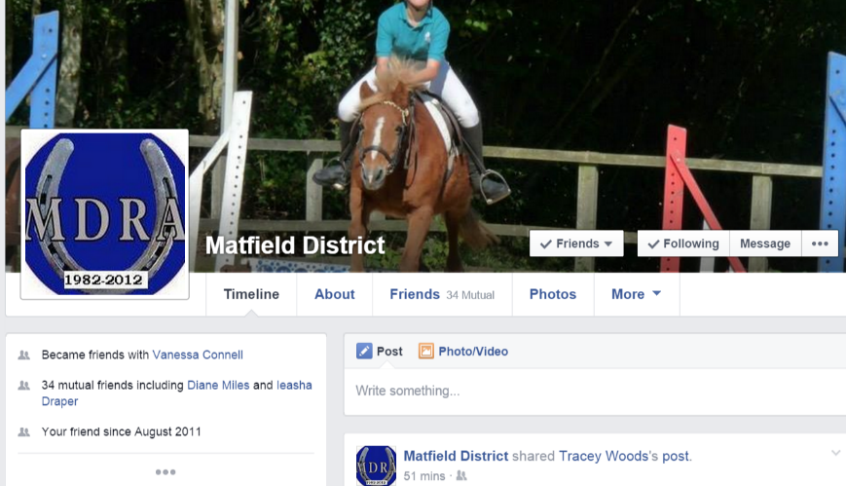
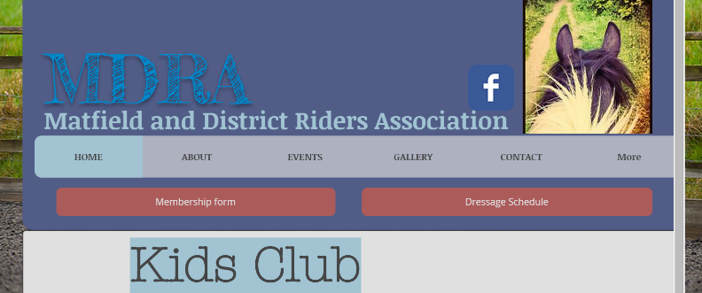

Archery: Giving Horseback archery a go.
Jenny Corbett
Warning : GOT spoilers alert.
In the non-existent summer of 2017 I watched in amazement at a scene in Game of Thrones. I’m not talking about THAT dragon. It was the scene of Dothraki soldiers advancing on the Lannister army behind a wall of fire (Dracaris!). I find the advance of a horse back army rather a stirring and powerful scene, like watching/being in the hunt, it reeks of power and force. The display was pretty cool, but then, they blew my mind. They even caused non horsey husband to exclaim with colourful language. The Dothraki stood up and placed one foot on the saddle (full gallop in herd) and drew their bows and arrows. It was amazing. If you want to see this, check it out they did a full show on the stunt riders and their work is incredible.
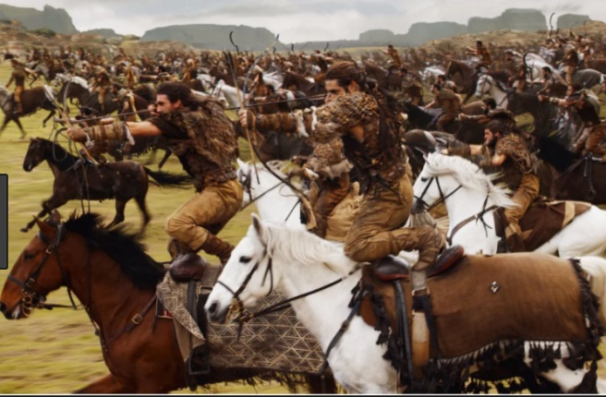
I wanted a piece of this, knowing full well I’m about as agile as a chubby fish on roller skates. I have always been a Robin Hood fan so I went hunting for the experience.
As luck would have it I found an advert for 4 spaces to try archery, on your own horse. This suited me as I never ride other horses really mostly due to my hefty stature, and I also I like Ludo to experience new things, literally in this case adding strings to his bow.
I asked around for a companion to join me, tricky, most were put off my almost all of it. My hero came in the form of Mr Miles, who set up Mrs Miles in a great fashion. Christmas present. Brilliant, Diane and Beau were signed up but had no idea, sweet.
As the day approached I began to mentally soil myself, can I even trot with no hand? Will ludo clear off when launching things off his back? Should I have practiced this? With the answer most likely to be a firm yes, I ignored it and cracked on.
Day arrives:
Lovely venue and people welcomed us to the yard and we were off. Isaacs Farm really are lovely people.
Step 1: Disclaimer: s&%t
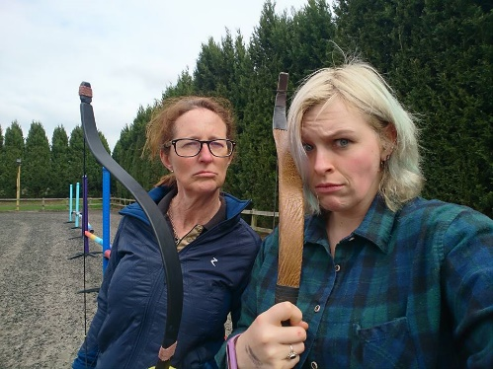
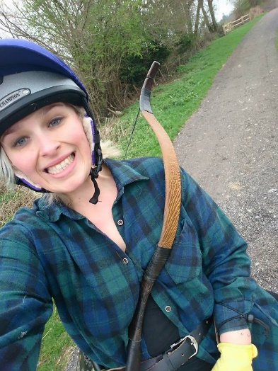
Step 2: Kit up
This part was cool, hip quiver, bow like Legolas and a leather yellow glove, yeah this was pretty cool. Then arrows (8 year old me is very excited, I’m Robin Hood).
Step 3: Practice knocking and shooting on the ground.
This part was hard, turns out doing archery properly is hard, even when you are wearing cool equipment. Especially hard is ‘knocking’ at speed (Getting arrows ready to fire) We tried static, then at a little walk. Still thoroughly crap, we went and got our steeds.
Step 4: Desensitisation.
This involves the instructor showing how it should be done (show off) while our horses stood and watched next to him. Ludo was cool with this, Beau needed a few more shots to chill out.
Then we got on, no turning back, brave pants on, we had to walk, trot and canter down the ‘shooting alley’ with no reins clapping as we went past target. Weirdly I really enjoyed this, I have never really dropped the reins before and I found this quite liberating cantering around the arena with no reins. Diane was monstrously brave as Beau can be a little pickle, but she did it and he was a good boy.
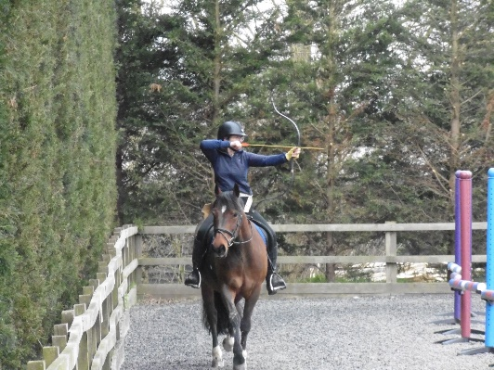
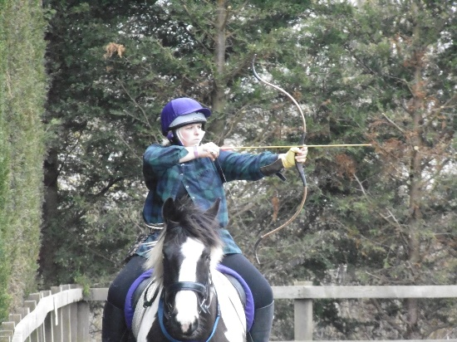

Step 5:Be Robin Hood.
So yeah, we were rubbish at the archery, scared of riding with no hands and so then we had to try all at once. Pfft, easy. Ludo was amazing at everything apart from the standing still next to the man with the arrows part, so our standing shots were a little rushed. Bloody hit the target on one of them though!
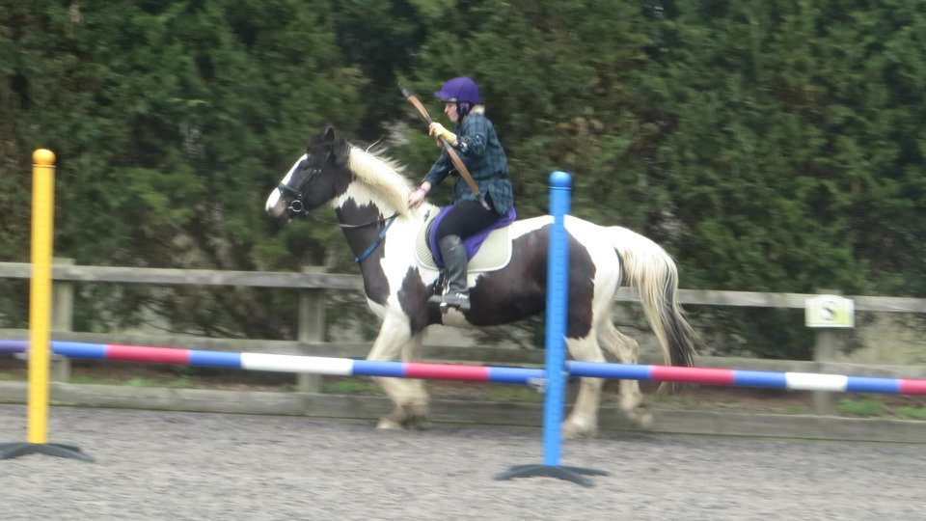
Then we had to move off and try in walk and canter. Well Ludo started pre-empting my shots and speeding up, so whilst I didn’t hit the target at anything faster than a walk, they moved in the general direction of the target and I felt like a movie hero. After my first canter shot I may have shouted out “I’m flaming Dothraki!!”. It was exhilarating and I wanted more. As with everything horsey it feels fast and furious and then you look at the video and its quite placid.
Diane and Beau blew us away with their display, although Diane should probably go into slapstick comedy, her timing for dropping the arrow out of position at the perfect moment for maximum laughs was incredible. More important than all of that, she looked fierce and rode beautifully in a stressful new situation.
We are hoping this opportunity will present itself again as the organisers want to set up a club, something I would love to get involved in. I learned that saying yes, and trying something new whilst daunting is worth it, you learn to share the fear, build trust with your horse and feel a little like you are making steps towards stunt rider stardom. Give things a try.

Dressage Sandhurst April 2018
There was sunshine, win. Well done to all competitors. These are the results below: (Just look at those scores – Well done!

Intro A walk and Trot Dressage 22/04/18
RIDER | HORSE/PONY | MEMBER | POINTS | PLACE
Katy Fleet | Mr Fuggles |  | 71.73% | 1st
Willow Pateney | Winnie |  | 71.52% | 2nd LR
Sarah Ribchester | Moriartys Match | yes | 68.91% | 2nd
Anne Wallace | Ernie | yes | 67.82% | 3rd
Laura Shave | Worsenden Oriando |  | 71.52% | 4th
Mia Dabir-Ajay | Sooty |  | 62.39% | 5th
Serena Murdoch | Nellie |  | 62.17% | 6th

Intro B walk and Trot Dressage 22/04/18

Lucy Kenworthy | Annie | yes | 73.69% | 1st
Katy Fleet | Mr Fuggles |  | 73.04% | 2nd
Melissa De Pascal | Ralph |  | 72.17% | 3rd
Sarah Ribchester | Moriartys Match | yes | 71.08% | 4th
Sophie Hollands | Duchess |  | 70.65% | 5th
Clare Sender | Labalands Royal Pageant | yes | 67.39% | 6th
Anne Wallce | Ernie | yes | 66.95%
Di Miles | Beau | yes | 66.52%
Louise Phipen | Raj | Yes | 64.13%

Prelim 7 Dressage 22/04/18
RIDER | HORSE/PONY | MEMBER | POINTS | PLACE
Ieasha Draper | Flash | Yes | 71.08% | 1st
Annette Green | MO |  | 70.22% | 2nd
Alice Davis | Pippen |  | 68.86% | 3rd
Libby Balmer | Tinks | yes | 68.63% | 4th
Molly Cogger | Nellie |  | 68.40% | 5th
Sydney Panteney | Chukkies |  | 67.95% | 6th
Prelim 13

EllieMcGilroy | Salvador |  | 80.76% | 1st
Jacks Stribbling | Freddie |  | 79.23% | 2nd
Ieasha Draper | Flash |  | 77.30% | 3rd
Libby Balmer | Tinks | yes | 70.00% | 4th
Anna o’donovan | Carrickview indelision |  | 69.61% | 5th
Evie Green | Mo |  | 68.00% | 6th

Events 2018

Date | Event | Location | Info
12th May 2018 | Clear round | Paddock wood,  Willow Lane | See Facebook event or website for details
7th July | Matfield Village Fete | Matfield Village Green | Come and see us on the green 12-4pm.
29th July 2018 | Summer Show | Paddock wood,  Willow Lane | Something for everyone.  Schedule coming soon to the website.
2nd September 2018 | MDRA challenge | Paddock wood,  Willow Lane | Dressage, jumping, le trek, lets do it! Info coming soon.

